**HH Dashboards**

**Dashboard 1 – Income Vs Expenses  
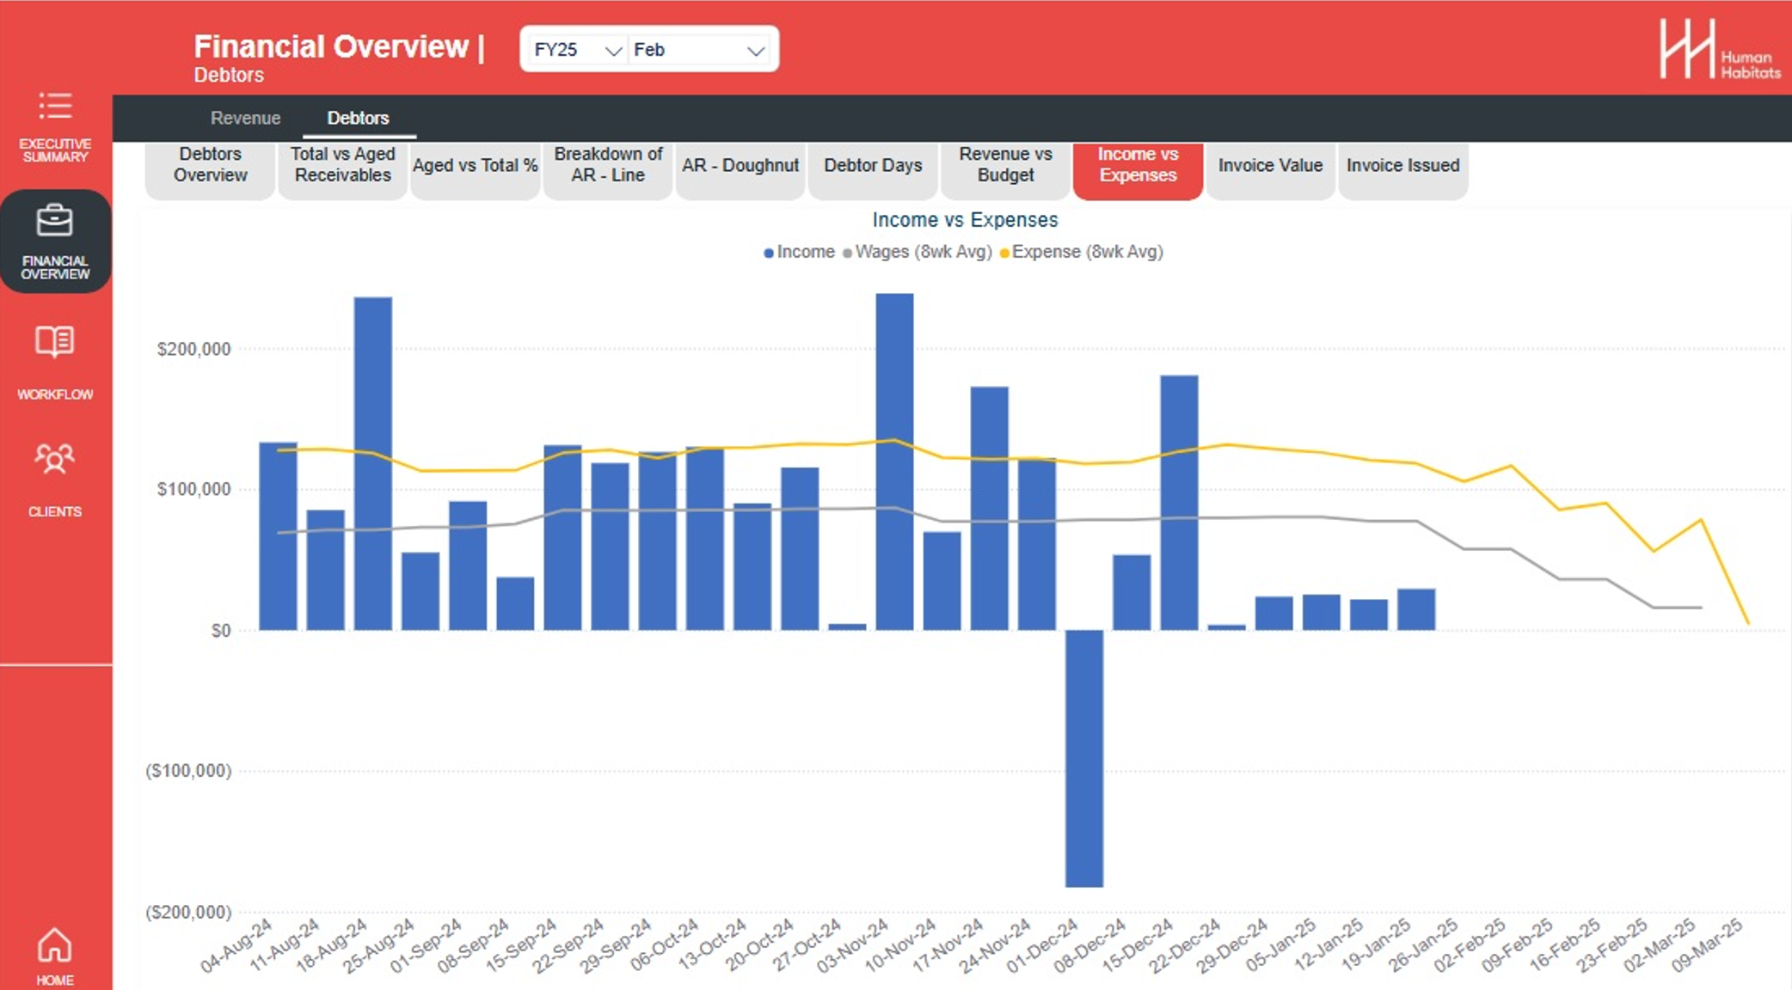**

Breaking down the above Dashboard into the 3 parts:  
  
**A. Income**  
Information for ‘Income’ can be found in Xero under:  
Dashboards – HH Trust Regular Account  
Then we use the data from the ‘Received’ and ‘Date’ columns, we would have to add up all the received values for each week using the date.  
***API callout****:* [*https://api.xero.com/api.xro/2.0/Payments*](https://api.xero.com/api.xro/2.0/Payments)

**B: Wages(8wk Avg)**

Information for ‘Wages’ can be found in Xero under:

Accounting – Reports – Budget Variance

Then we use the data from ‘Wages and Salaries’ row, in the screenshots below I have modified the report to show 1 weeks’ worth of wages, we would have to extract all the wages and salaries data, process by date and apply our rolling 8 week formula. Wages and salaries looks like its and account and can be extracted as an account.

**Account =** 500 – Wages and Salaries

***API callout****:* [*https://api.xero.com/api.xro/2.0/Reports/ProfitAndLoss*](https://api.xero.com/api.xro/2.0/Reports/ProfitAndLoss)

1. *We then filter out by AccountName == "Wages and Salaries".*
2. *Add a new column called “52-Week Moving Avg”.*
3. For each row, it finds all rows in the last **52 weeks** up to the current row’s ToDate (strictly greater than currentDate - 51*7 days and ≤ currentDate).

*Custom1 =*

*Table.AddColumn(*

*Table.Sort(#"Grouped Rows", {{"ToDate", Order.Ascending}}),*

*"52-Week Moving Avg",*

*(currentRow) =>*

*let*

*currentDate = currentRow[ToDate],*

*pastRows = Table.SelectRows(#"Grouped Rows",*

*(r) => r[ToDate] <= currentDate and r[ToDate] > Date.AddDays(currentDate, -7*51)),*

*avg = List.Average(pastRows[Amount])*

*in avg*

*)*

1. Average their Amount values.

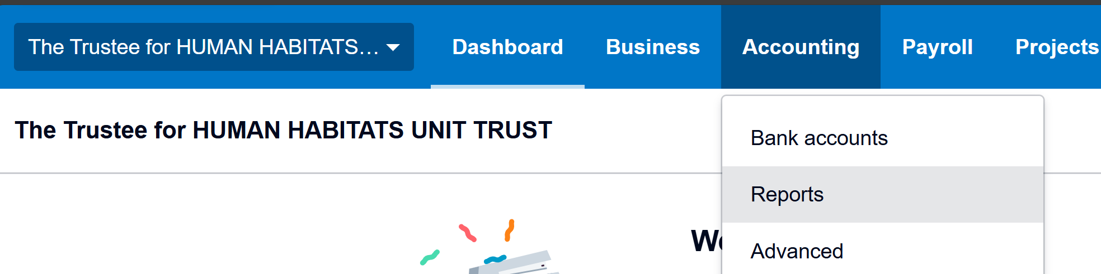

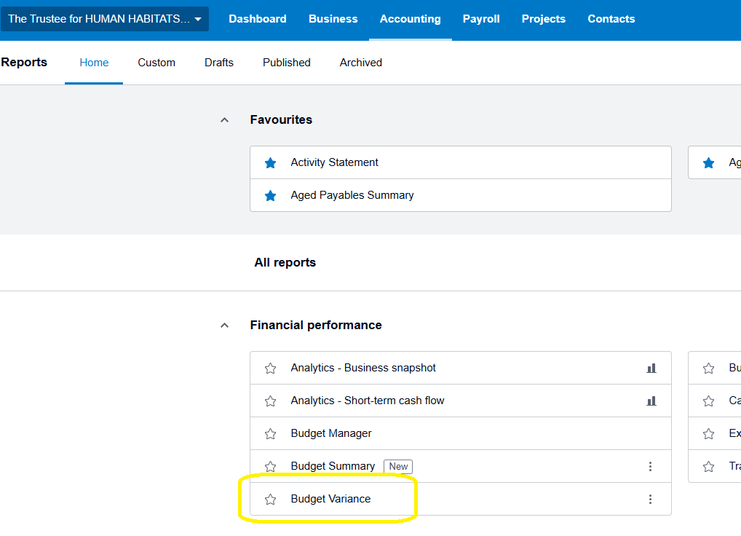

Example of week of wages filter

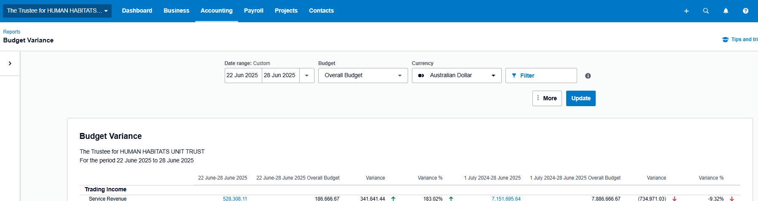

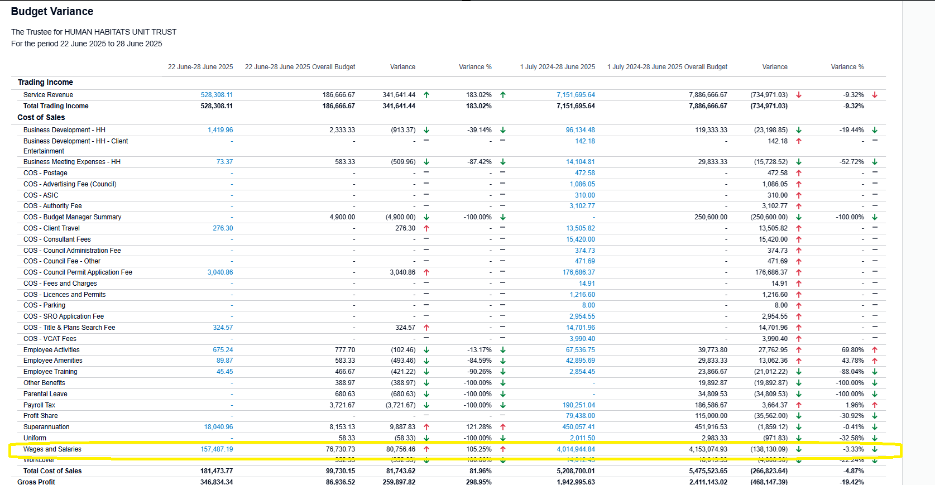

**C. Expenses(8wk Avg)**

Information for ‘Expenses’ can be found in Xero under:

Accounting – Reports – Budget Variance

Then we use the data from ‘Total Cost of Sales’ row + ‘Total Operating Expenses’ row, Like the Wages and Salaries, we would have to extract both of these rows, process by date and apply our rolling 8 week formula. Wages and salaries looks like its and account and can be extracted as an account.

***API callout****: :* [*https://api.xero.com/api.xro/2.0/Reports/ProfitAndLoss*](https://api.xero.com/api.xro/2.0/Reports/ProfitAndLoss)

1. *We then filter out by AccountName == "* *Total Cost of Sales" and “Total Operating Expenses”.*
2. *Add a new column called “52-Week Moving Avg”.*
3. For each row, it finds all rows in the last **52 weeks** up to the current row’s ToDate (strictly greater than currentDate - 51*7 days and ≤ currentDate).

*Custom1 =*

*Table.AddColumn(*

*Table.Sort(#"Grouped Rows", {{"ToDate", Order.Ascending}}),*

*"52-Week Moving Avg",*

*(currentRow) =>*

*let*

*currentDate = currentRow[ToDate],*

*pastRows = Table.SelectRows(#"Grouped Rows",*

*(r) => r[ToDate] <= currentDate and r[ToDate] > Date.AddDays(currentDate, -7*51)),*

*avg = List.Average(pastRows[Amount])*

*in avg*

*)*

1. Average their Amount values.

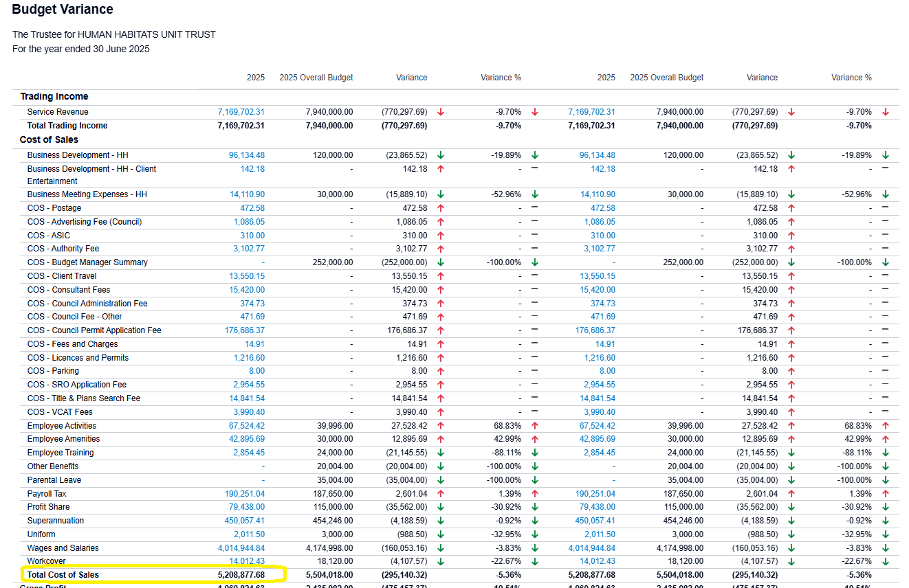

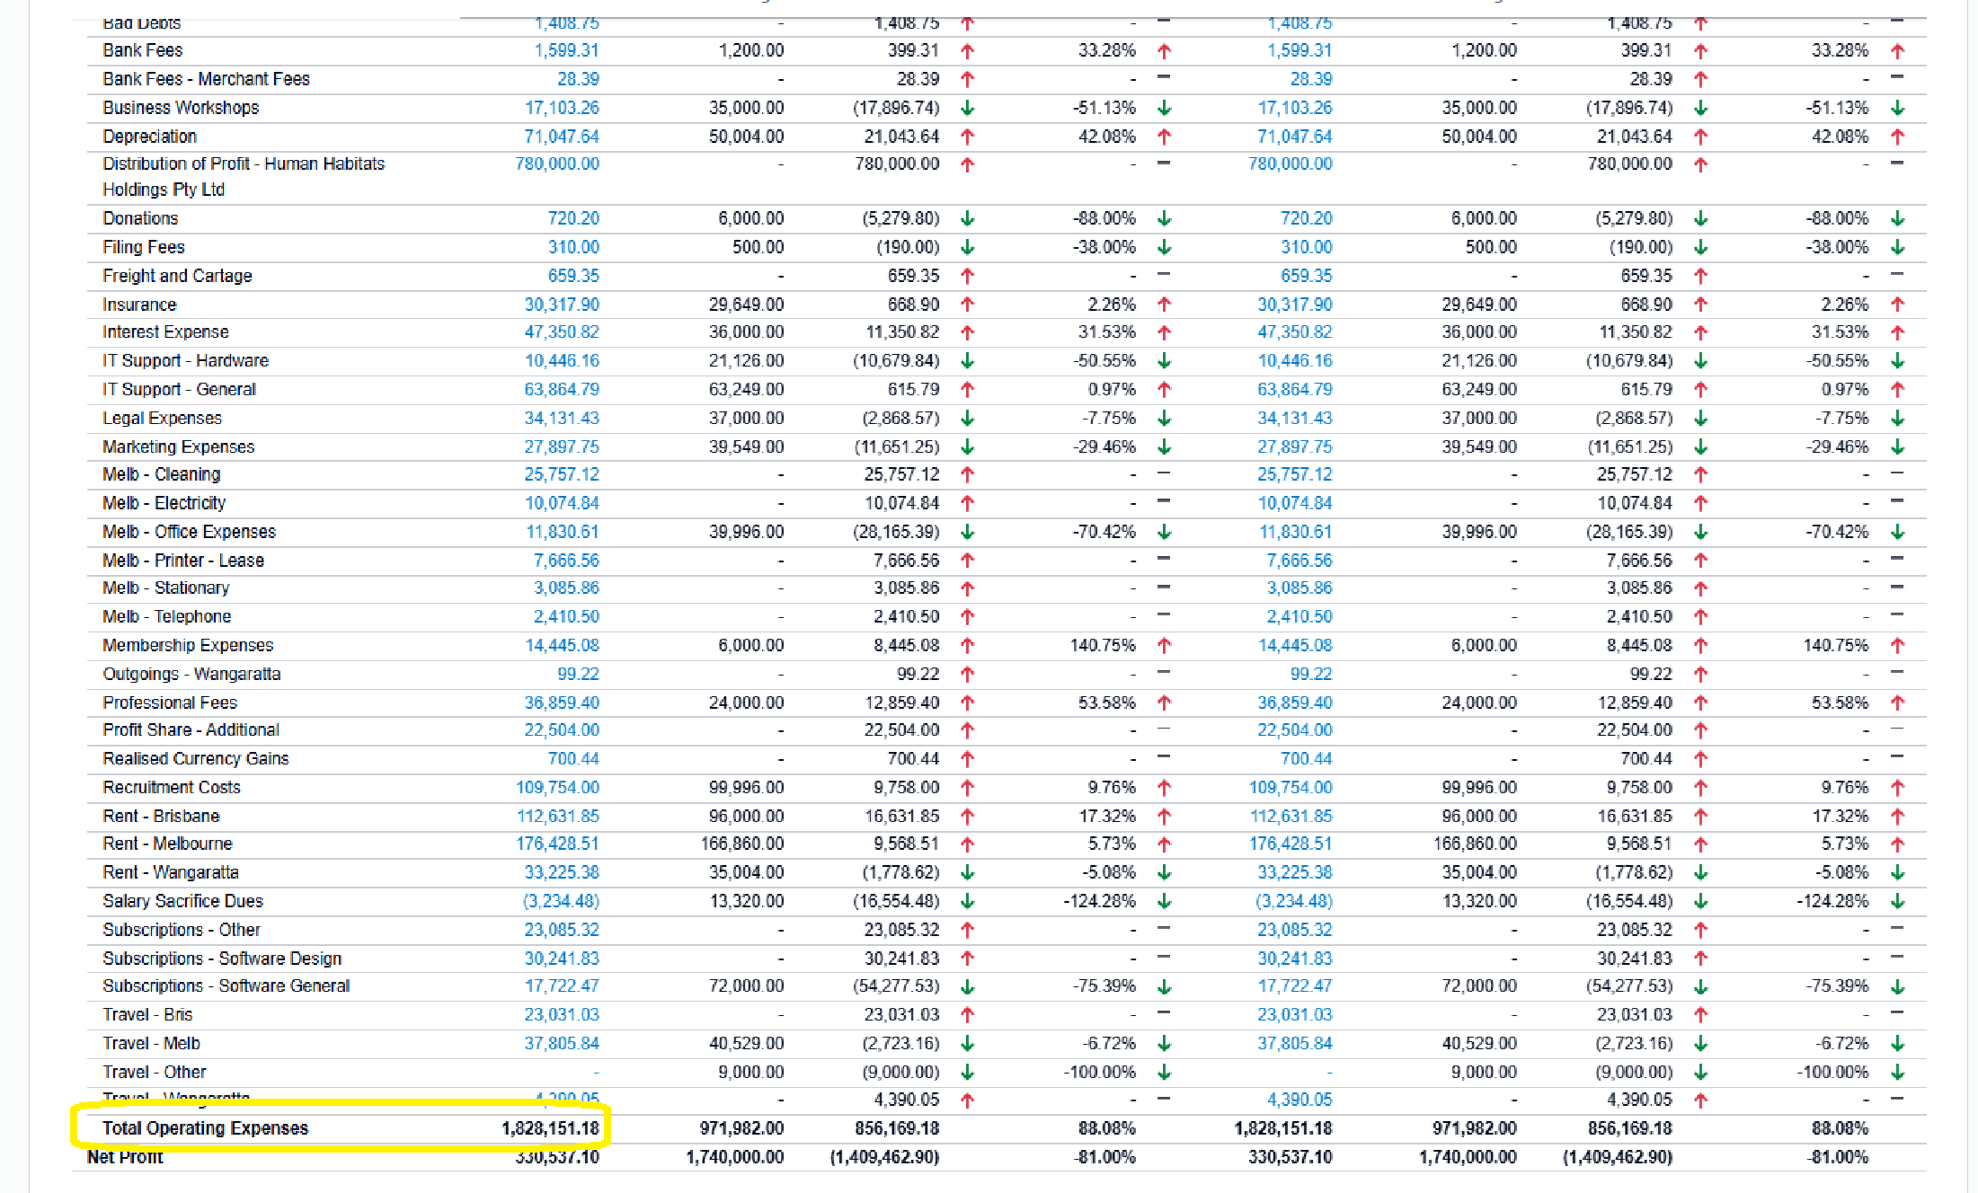

**Dashboard 2 – Monthly Invoicing to Budget**

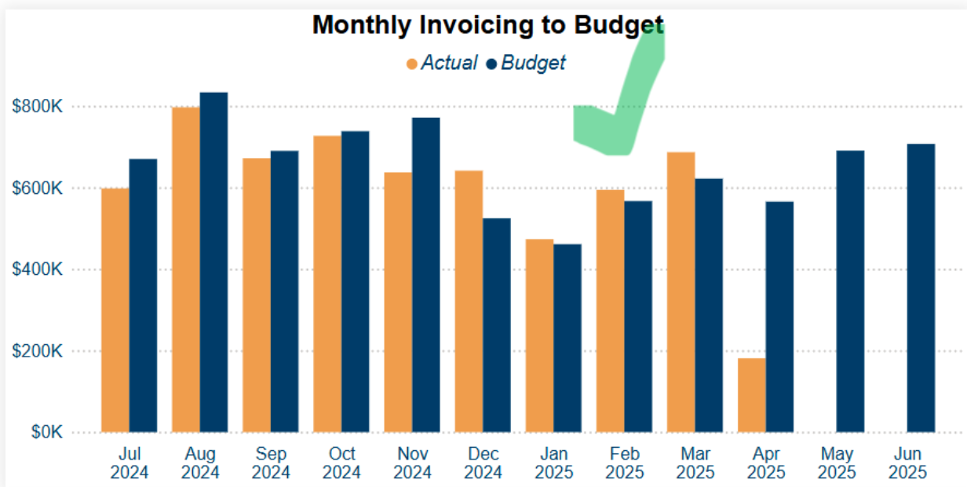

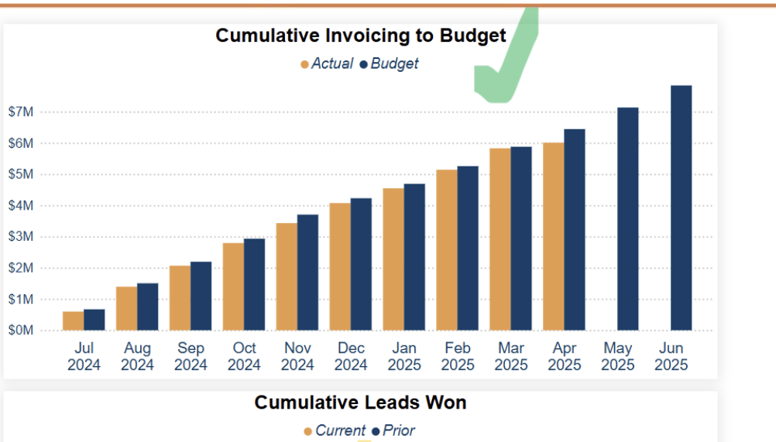

This Uses the same report as Dashboard 1 for both of the values  
Accounting – Reports – Budget Variance  
Then we use the data from the ‘Total Trading Income’ row, and the first 2 columns, Actual and Budget, to display each months values.

***Budget API callout****:* [*https://api.xero.com/api.xro/2.0/Reports/BudgetSummary*](https://api.xero.com/api.xro/2.0/Reports/BudgetSummary)

1. Return 12 months of budget values for the specified financial year
2. Expand the nested **Amounts** table on each line into columns **Date** and **Amount** (one row per month).
3. Keep only the **Service Revenue** budget line.

***Invoicing API callout****:* <https://api.xero.com/api.xro/2.0/Payments>

1. Keep only rows where PaymentType = "ACCRECPAYMENT"

May have to do some work on how to get this data out of Xero

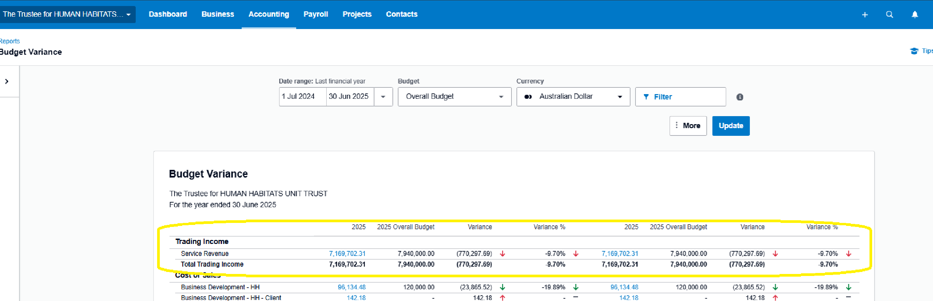

**Dashboard 3 – YTD View and Monthly View**

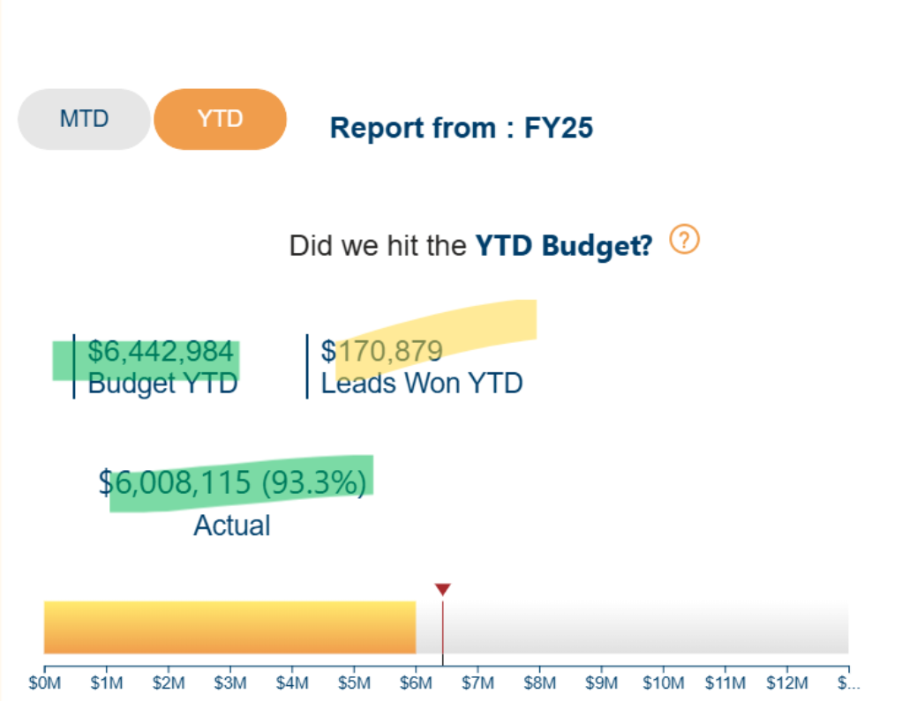 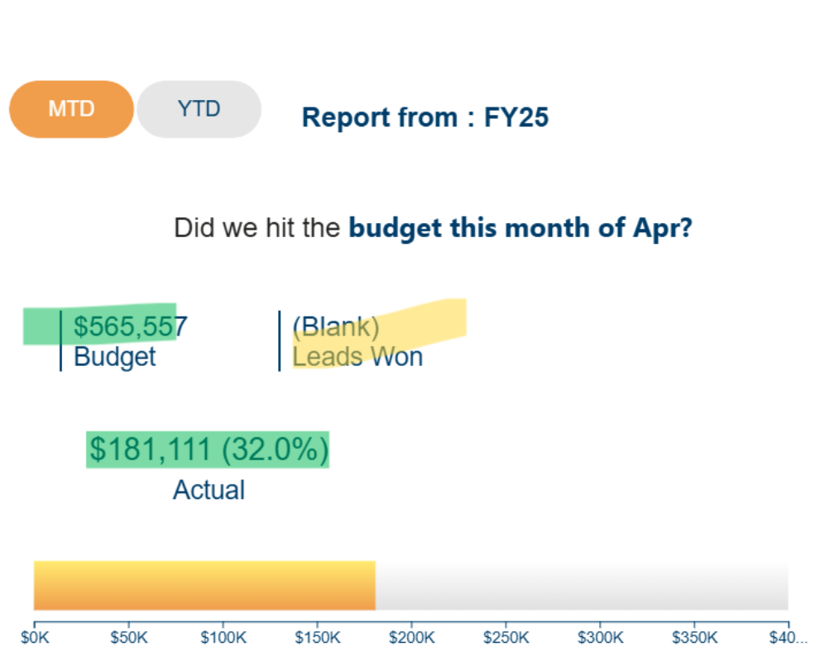

These 2 widgets have the exact same information as Dashboard 2, just displayed in a different format.

***NOTE****: this is 1 widget with 2 selectors – Monthly and Yearly view*

**Dashboard 4 – Work In Progress(WIP) By Team**

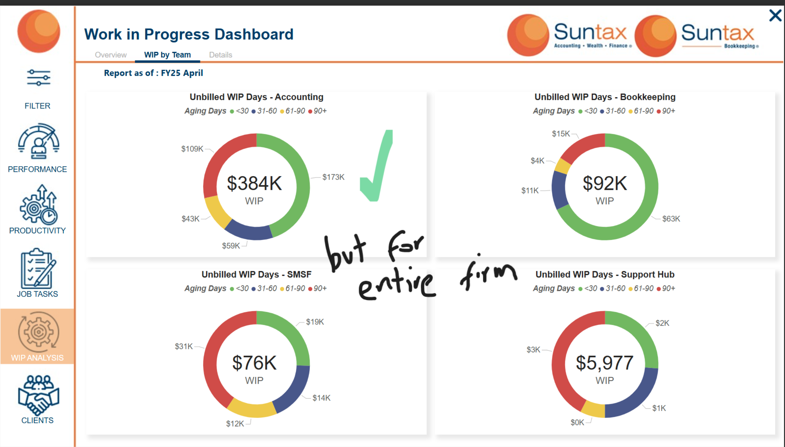

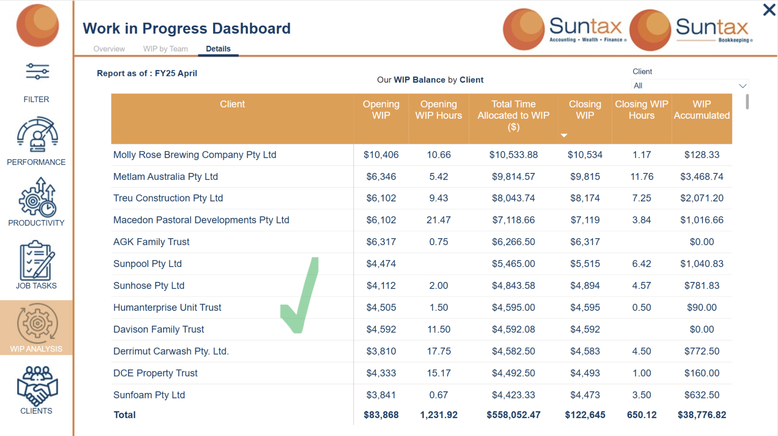

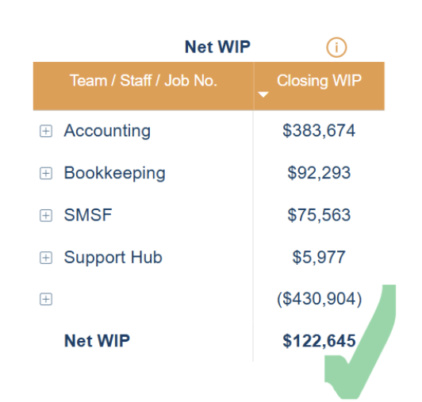

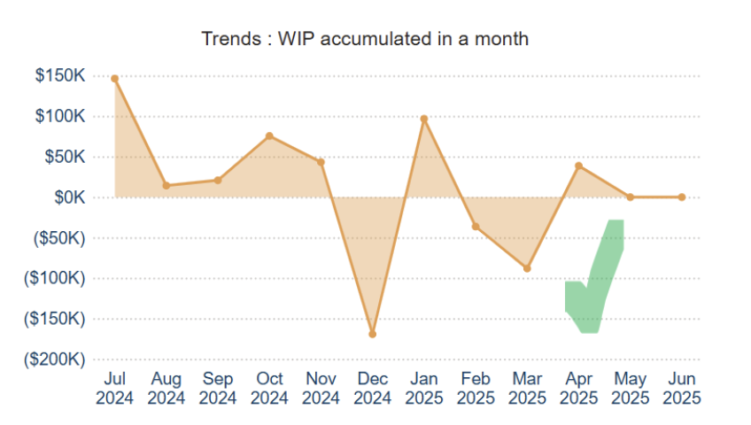

All WIP data lives inside Workflow Max or XPM  
  
***Endpoints required***

* ***Jobs*** *– drive the list of in-progress jobs you want to value:  
  GET https://api.xero.com/practicemanager/3.1/job.api/get/{jobNumber}.*
* ***Time*** *– fetch timesheet entries for a job (filter by date range):  
  GET https://api.xero.com/practicemanager/3.1/time.api/job/{jobNumber}?from=YYYYMMDD&to=YYYYMMDD.*
* ***Costs*** *– pull disbursements/expenses attached to the job (materials, outlays):  
  GET https://api.xero.com/practicemanager/3.1/cost.api/list?page=1 (filter by job/uuid in query).*
* ***Invoices*** *– retrieve invoices against the job to subtract amounts already billed: GET https://api.xero.com/practicemanager/3.1/invoice.api/get/{invoiceNumber} (there are job/invoice listing routes too).* 
  1. Use **job state/status** to include only active/in-progress jobs.
  2. Pull **time** entries and value them using the entry’s charge rate / task rate (as returned by the time API).
  3. Pull **costs** (disbursements) that are billable and not yet invoiced.
  4. Subtract **invoices** (progress/final) allocated to that job up to the cutoff.

This is where the data will be found in WFM

Business – Work In Progress  
All the data in this page can be used for WIP  
  
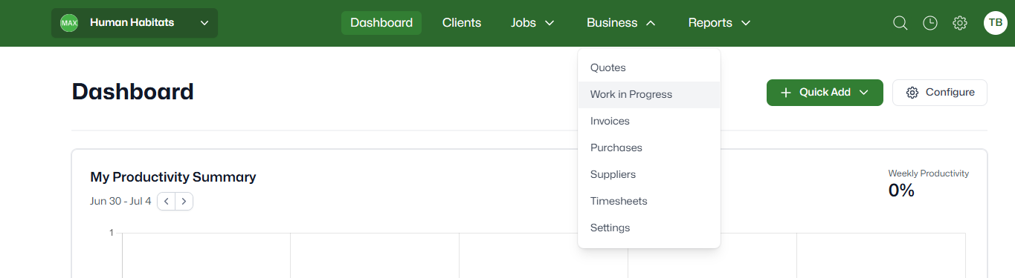

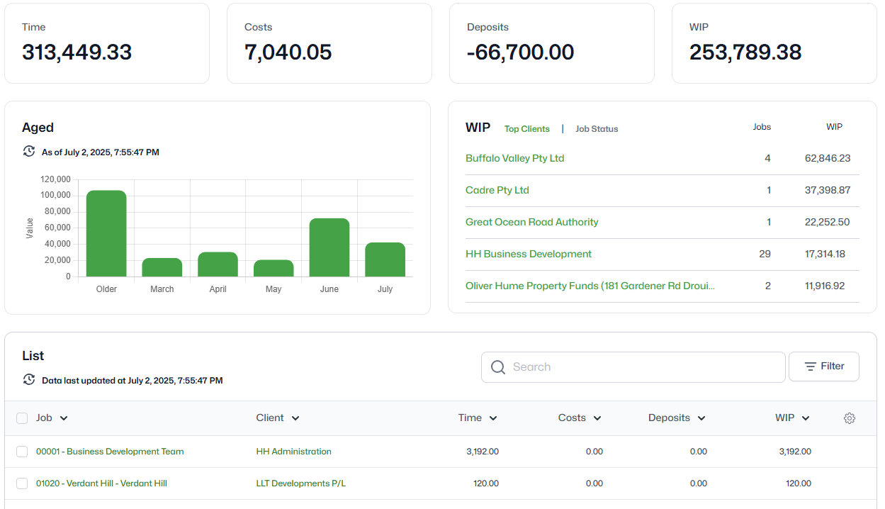

**Dashboard 5 – ATO Lodgment Status and Progress**

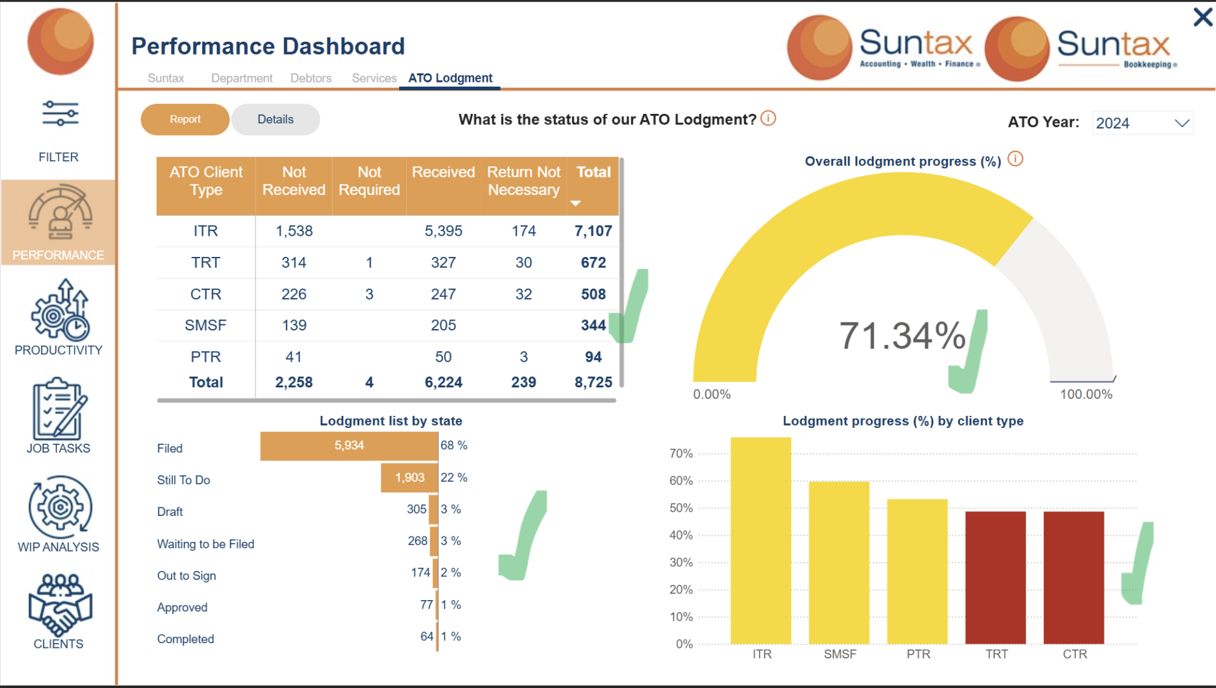

**NOTE:FURTHER INFORMATION REQUIRED FROM SUNTAX**

**No API’s seem to be available for this category, will check with Suntax and update**

**Dashboard 6 – Services**

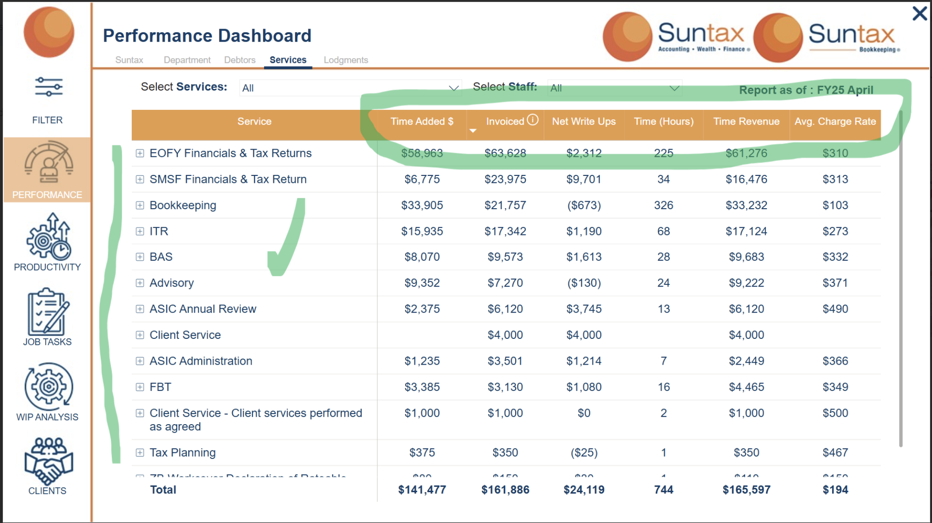

**XPM APIs required**

* **Time** – lists timesheet entries (hours, billable flag, task, staff, job, dates). Use this for **Time (Hours)** and the value of time:  
  GET https://api.xero.com/practicemanager/3.1/time.api/list?from=20250101&to=20250131
* **Invoices** – get invoices (amounts, job linkage) to compute **Invoiced** and to derive **Net Write Ups** (see formula below):  
  GET …/invoice.api/get/{invoiceNumber}
* **Jobs** – to filter/segment by client, job status, manager, etc. (helps scope your dataset to “active” work):  
  GET …/job.api/get/{jobNumber}
* **Tasks** and/or **Categories** – use these to group by your “Accounting services” buckets (BAS, ITR, Bookkeeping, FBT, ASIC Admin, Client Service). Practices typically map these through Task codes or Categories:  
  GET …/task.api/list and/or GET …/category.api/list

1. XPM values time using **staff/task billable rates** (configurable). That produces a “charge value” you need for $$ calculations.
2. “Write-on/off” isn’t surfaced as a simple API field; you compute it from time value vs invoiced value.

## **How to compute each dashboard column**

Let your grain be **Service (Task/Category) × Period (e.g., month) × Client/Job (optional)**.

1. **Time (Hours)**  
   Sum hours from **Time** entries in the period, filtered to billable work if that’s your definition. [developer.xero.com](https://developer.xero.com/documentation/api/practice-manager-3-1/time?utm_source=chatgpt.com)
2. **Time Added $** (aka “charge value” of time entered)  
   For each time entry: hours × billable rate (rate comes from XPM’s staff/task rate hierarchy, yielding the charge value). Sum by Service. [support.linkacademy.com+1](https://support.linkacademy.com/hc/en-us/articles/360002205875-Xero-Practice-Manager-Staff-Settings-Staff-Billable-Rates?utm_source=chatgpt.com)
3. **Invoiced**  
   Sum **Invoices** amounts in the period, linked back to jobs (and ideally allocated to tasks/services if you do task-based billing or use categories on invoice lines). [developer.xero.com](https://developer.xero.com/documentation/api/practice-manager-3-1/invoices?utm_source=chatgpt.com)
4. **Time Revenue** (realised revenue attributed to time)  
   Pragmatic approaches:
   * If you allocate invoices by **task/service**: sum invoice lines for that service = Time Revenue.
   * If not allocated at line level: apportion each invoice across the job’s services **pro-rata by Time Added $** in the same period/job. (Common workaround since XPM doesn’t return a “realised per time entry” field.)
5. **Net Write Ups**  
   Net Write Ups = Invoiced – Time Added $ (by the same grouping and period). Positive = write-on; negative = write-off. This mirrors XPM’s concept used in the Fees & Write On/Off reporting. [central.xero.com+1](https://central.xero.com/s/article/Fees-and-Write-On-Off-Report?utm_source=chatgpt.com)
6. **Avg. Charge Rate**  
   Avg. Charge Rate = Time Revenue ÷ Time (Hours) (or use Time Added $ if you prefer pre-invoice charge rate).

**Dashboard 7 – Debtors**

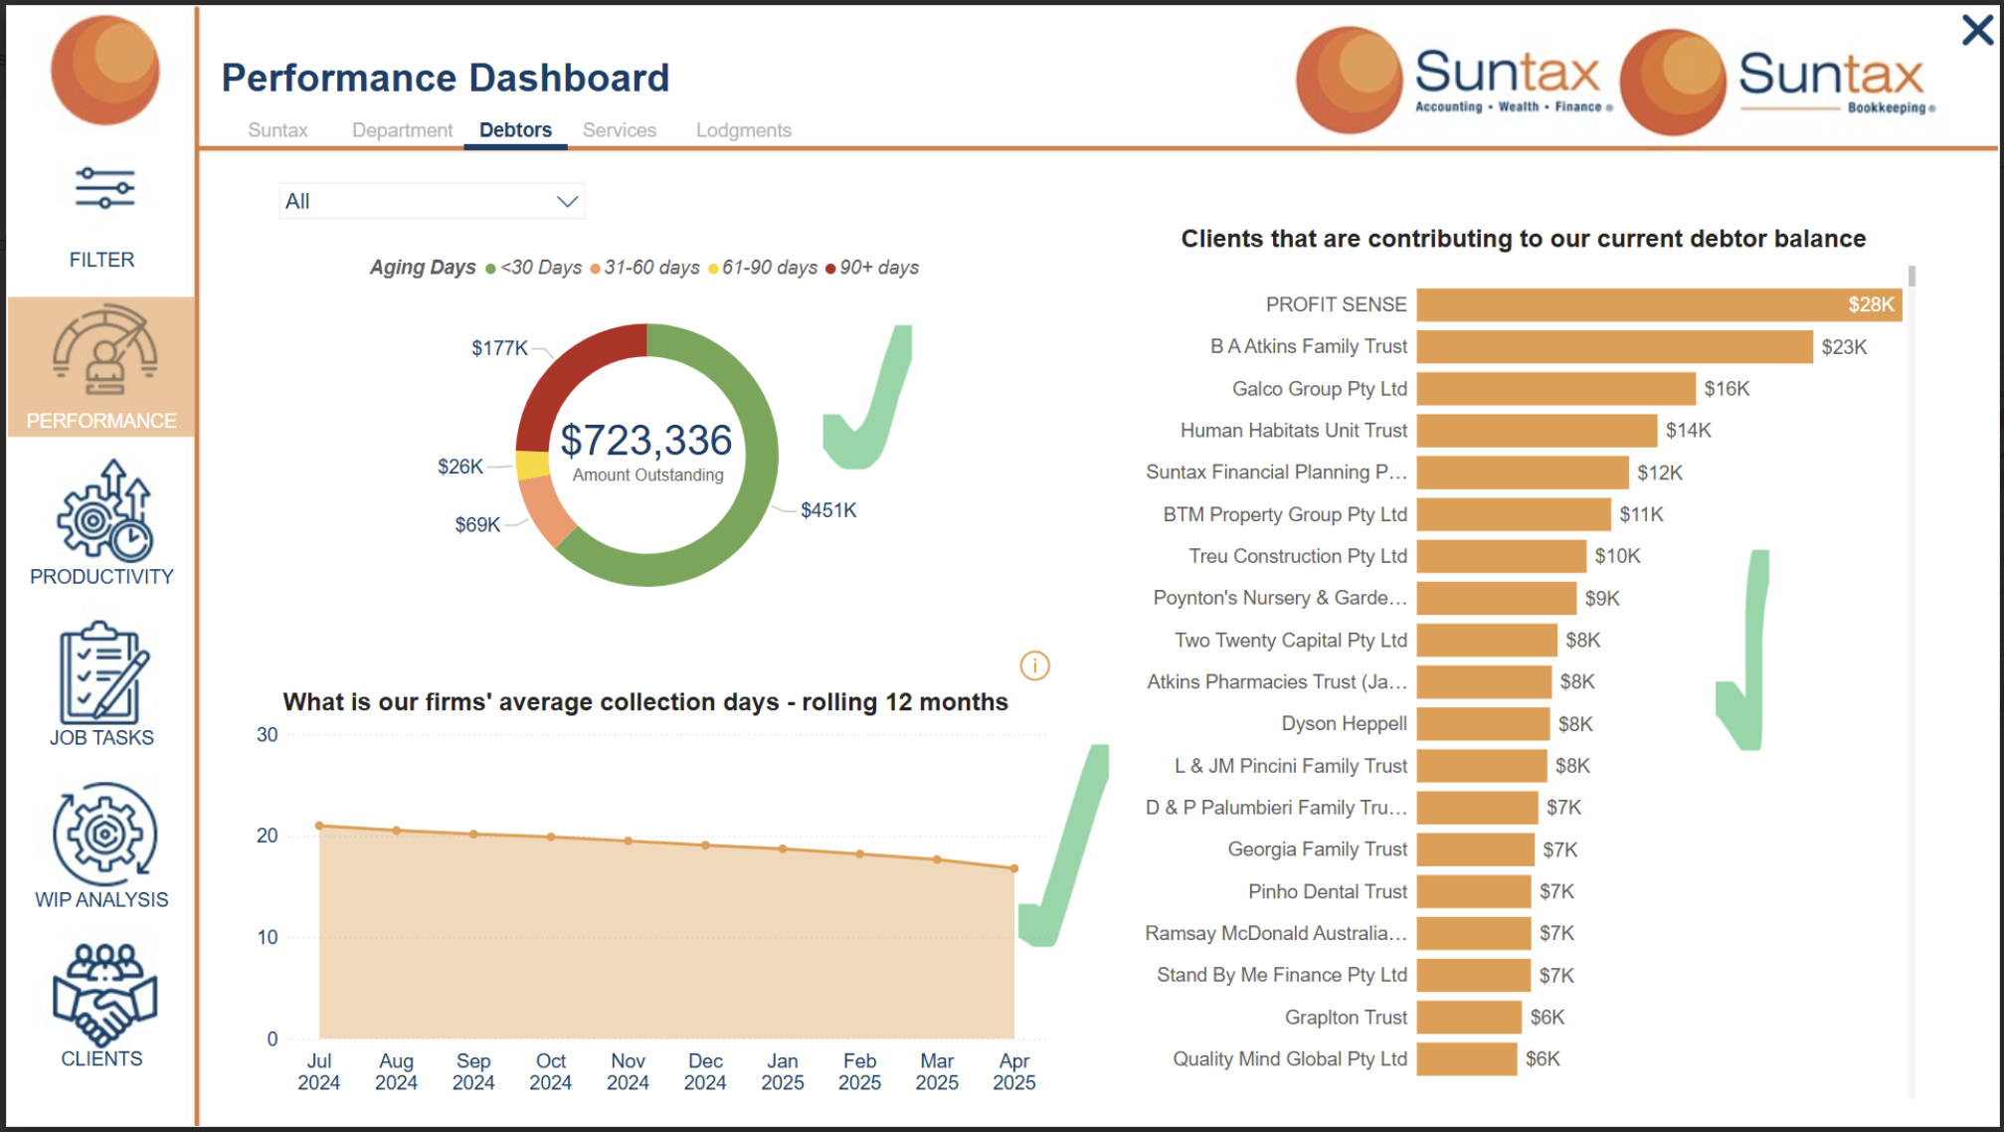

**API calls**

* GET /api.xro/2.0/Invoices (filter to Type=ACCREC and Status in (AUTHORISED, PAID, PARTPAID); page through) — includes AmountDue, AmountPaid, Date, DueDate, Contact, and (when expanded) Payments you can use for “days to collect”.
* GET /api.xro/2.0/Contacts (to join names, groups, etc.).

**Ageing buckets (as at Date X)**  
For each **open** invoice (AmountDue > 0 at Date X):

* < 30: if 0 < days_overdue <= 30
* 31–60: if 31 <= days_overdue <= 60
* 61–90: if 61 <= days_overdue <= 90
* 90+: if > 90  
  Where days_overdue = DateX − DueDate (clip at 0 when not yet due).

**Client debtors chart**  
Group SUM(AmountDue) by Contact.

**Rolling 12-month collection days (DSO)**  
Two common methods:

* **Invoice-level (actual days to collect):** for fully paid invoices, compute  
  days_to_collect = (max(PaymentDate) − InvoiceDate) using the invoice’s **Payments** array; average by month of invoice date. (Good behavioural signal.)
* **Classic DSO:** for each month m,  
  DSO(m) = (Average AR balance in m ÷ Credit Sales in m) × Days_in_m. (Uses your AR balance snapshot + sales.)

**Dashboard 8 – Client Recoerability**

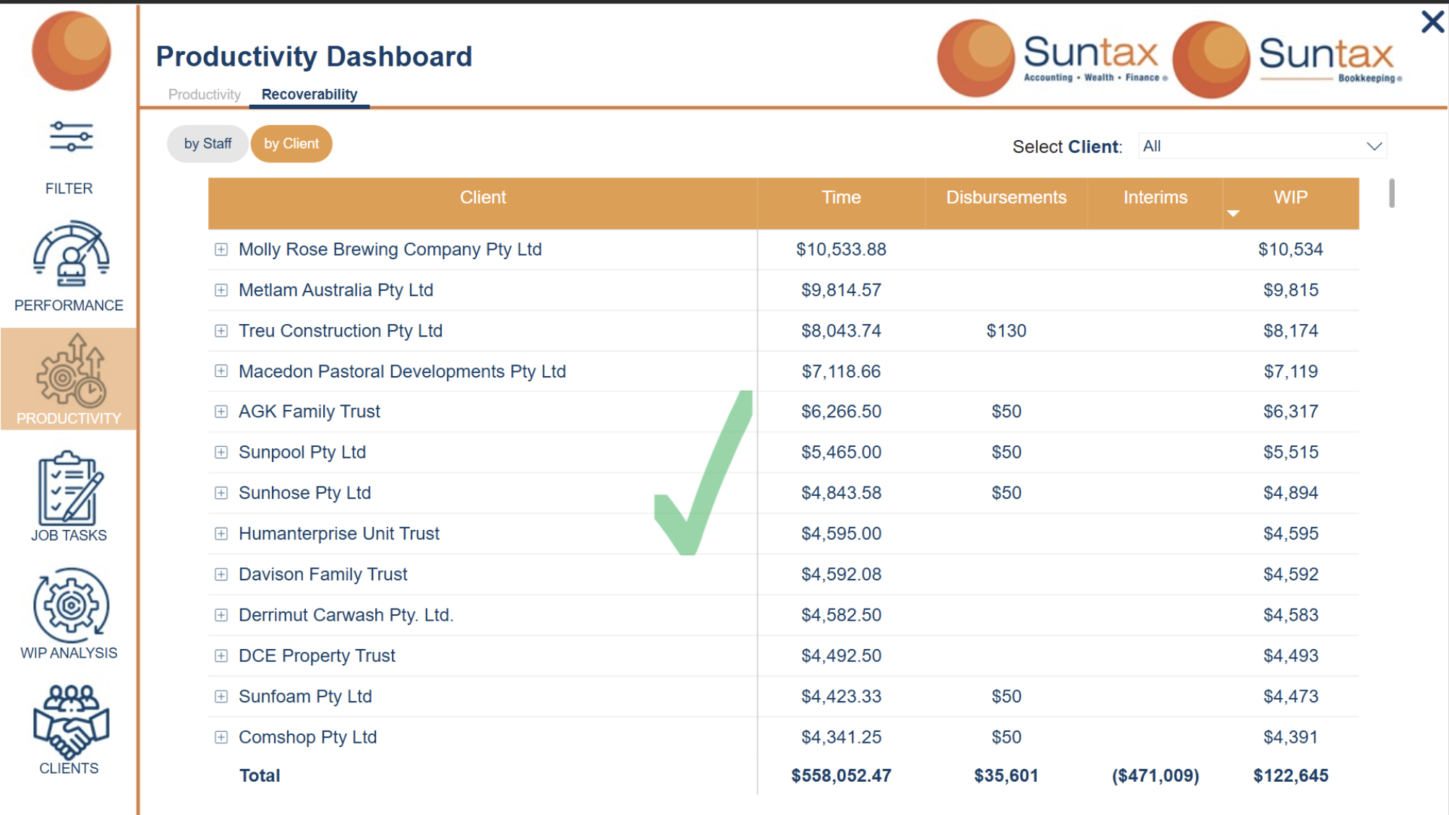

**APIs to call**

* **Time** → hours + charge value per entry (billable vs non-billable, staff/task rate). Use for **Time ($)**:  
  GET https://api.xero.com/practicemanager/3.1/time.api/list?from=YYYYMMDD&to=YYYYMMDD
* **Costs** → disbursements/expenses on jobs. Use for **Disbursements**:  
  GET …/cost.api/list?page=1
* **Invoices** → progress/final invoices; imported invoices from Xero show in XPM and behave as **Interims** (negative WIP) until “wash-up”. Use for **Interims** totals:  
  GET …/invoice.api/get/{invoiceNumber}
* **Jobs** / **Clients** → IDs, names, and filtering (active jobs, client mapping).   
  GET …/job.api/get/{jobNumber} • GET …/client.api/* (use clientUuid)

XPM WIP = **uninvoiced time and disbursements** on jobs; interims and write-offs affect that balance.

**Compute your columns (by Client, within a chosen period)**

* **Time ($)**: Sum charge value of **billable** time entries from **Time API** (hours × charge rate per entry).
* **Disbursements**: Sum **billable** costs from **Costs API** (materials/outlays) for the client’s jobs.
* **Interims**: Sum invoice amounts that are **interim/progress** (including invoices imported from Xero into XPM) for those jobs; these act as **negative WIP** until washed up.
* **WIP** (at a cutoff date):

WIP = (billable Time $ to date)

+ (billable Disbursements to date)

– (Interims applied to date)

– (Write-offs applied to date, if any)